

VILNIUS UNIVERSITY
ŠIAULIAI ACADEMY
BACHELOR PROGRAMME SOFTWARE ENGINEERING

Software Engineering
Project Draft
Donation Web service

Group members: Daniil Arbatov, Hanna Asiadouskaya, Ivan Kapusta, Artem Shymko

Lecturer: dr. Mykolas Okulič-Kazarinas

Šiauliai, 2024
Description:
Web service that assists with raising money for specific goals in different areas. Different services can upload their needs for fundraising.
At the current state:
Developed Functional and Non-functional requirements, Concept of Operation, Requirement Analysis and Software Requirements Specifications.
Goal:
Build web service in 4 months, preserving the best possible quality of end product.
Stakeholders:
  - Military
  - Health services
  - Animal shelters
  - Homeless shelters
  - Orphanages
  - Educational facilities in need
  - Retirement homes
  - Grants coordinators
  - Government
  - Customers who wish to donate
  - Banking services
  - Advertisers
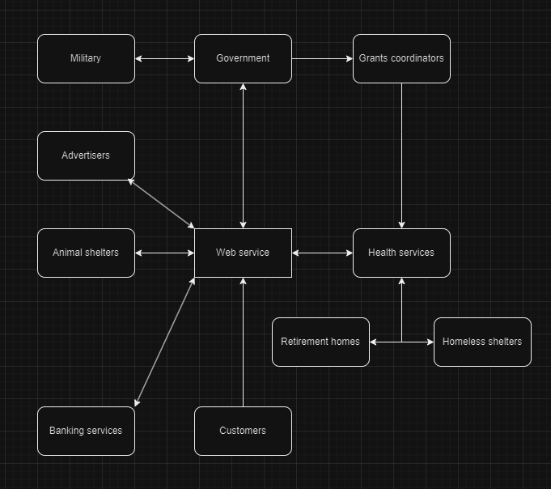
Project management method:
The project has the Agile methodology, specifically utilizing the Kanban framework, from its beginning to the present stage. The Kanban board has proven to be suitable tool for us, providing both flexibility and continuous optimization of the workflow. This method enables the team to effectively visualize tasks, prioritize work in progress, and maintain a steady flow of deliverables.
Kanban reduces pressure on employees by eliminating frequent meetings and tracking progress through simple categories like "To Do," "In Progress," and "Done." This saves time and makes the development process easier to manage without using complex units like epics or story points.
Employees:
- Product Owner:
  - helps understand what stakeholders want and communicates with other departments to make sure the product satisfies everyone.
- Sales representative:
  - helps customers find what they need, make deals, and work to keep both the company and customers satisfied.
- Software Engineers:
  - develop the software
- UI/UX Engineers:
  - design clear and easy user interface
- QA department:
  - helps software and UI/UX engineers to create the final product. Looks for any unsolved bugs in the program.
- Server Department:
  - make sure all the company's computers and servers are working properly, fixing any problems and keeping everything secure.
